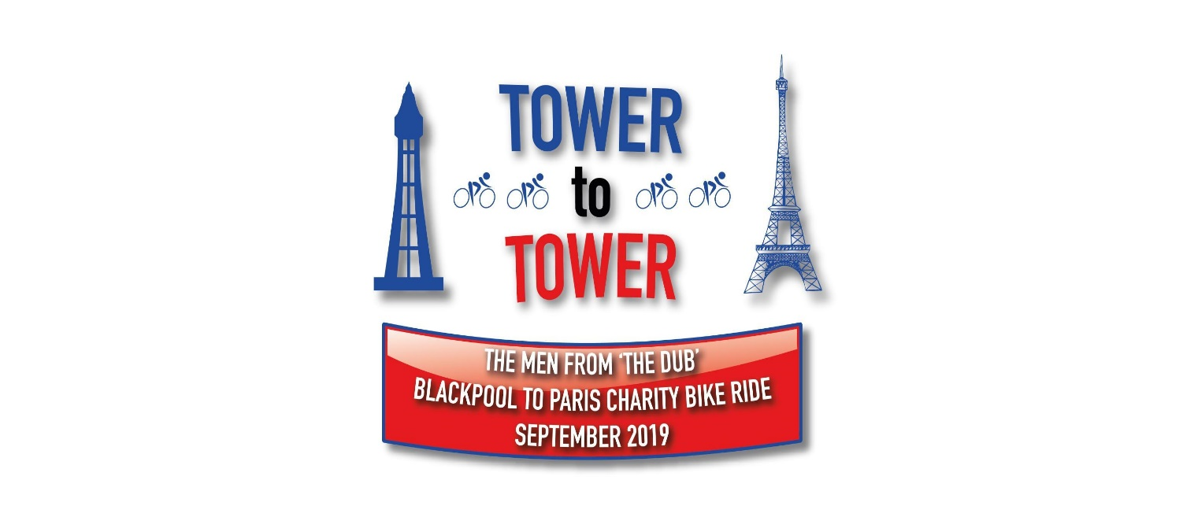

In 2017, Wrea Green’s ‘Men from the Dub’, Mark Wildish, Jim Clarke, Richard Millar & Jim Bretherton embarked on their first cycling challenge, riding 170 miles in two days. They cycled Coast to Coast from Lytham to Bridlington for a local Wrea Green charity, the ‘Richard Wilson Sports Foundation’. They managed to raise a fabulous £1000.00 to help support local young sporting talent and clubs. Two years later, they set themselves another cycling challenge, this time it would be more miles and another Country not County!

As usual, this challenge idea came about after a few light refreshments... It gathered some momentum, and after a bit of persuasion on the 22nd September 2019, our “Men from the Dub” took on the Tower to Tower bike challenge, cycling from Blackpool Tower to the Eiffel Tower in Paris, raising much needed funds for Cancer Research UK. Anurag Sharma was also part of the Tower to Tower team, driving the support vehicle, providing safety, spares & motivation to keep those pedals turning!

The journey started off by a very windy sea front on the Comedy Carpet at Blackpool Tower, then the boys headed off through Wrea Green where they were met by a true heroes send off at Dizzy Ducks. The support provided by families and friends cheering them off on a very wet Sunday morning was both emotional and overwhelming. Once fuelled up on bacon butties and tea, they all set off on their epic challenge cycling from England to France in just 6 days. The boys endured several days of consistently wet and windy weather, along with suffering several punctures, broken pedals and lights that failed in the dark. However, with the power of social media and Anurag’s outstanding interview and journalism skills, everyone was kept updated on all of the action including a mention from Chris Evans at Virgin Radio!

With great determination to get to the finish line, the Men from the Dub achieved their goal on the 27th September 2019 at the Eiffel Tower in Paris. All of the families flew out to meet our local heroes, with everyone waiting in anticipation, wearing Cancer Research tops, waving flags and holding banners for their arrival. The guys were absolutely thrilled to get to the end of the challenge and meet their families, however they were even more pleased to realise the amount of money which has been raised through this self funded event. The team wanted to raise at least £2000.00 and so far they have raised on excess of £6000.00!.

We are all extremely proud of what has been achieved through this magnificent team effort. The support provided by colleagues, families, friends and the exceptional following from the local community has been inspiring.

Thank you so much to everyone who has supported the challenge. I wonder what will be next?!!!

Every penny you donate goes to putting an end to cancer, so
please help them to raise as much as possible & donate on the link below:

https://fundraise.cancerresearchuk.org/page/menfromthedub

