Footway Works – Poulton Street, Kirkham, Fylde.
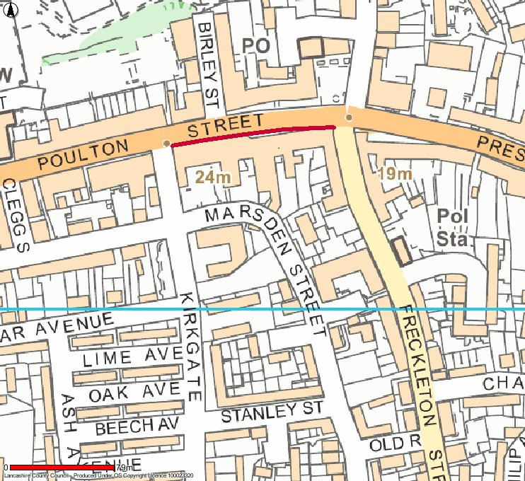
This map is reproduced from Ordnance Survey material with the permission of Ordnance Survey on behalf of the Controller of Her Majesty’s Stationary Office © Crown Copyright. Unauthorised reproduction may lead to prosecution or civil proceedings. Lancashire County Council – OS Licence 100023320

Length of footway works:

Footway improvement works will be undertaken on the south side of Poulton Street between Kirkgate and Freckleton Street. Work is planned to be undertaken during late afternoons/evenings to avoid major disruption to the local area. Some work may be carried out during daytimes, but this should cause limited disruption.

It is expected works will start 14 January 2013 and last for 5 weeks. The road will not be closed but may be subject to temporary traffic signal control. The footpath may be restricted during work operations.

Pedestrian access and access to properties within the Works Area will be maintained at all times.

Key
Proposed footway works

